**Section 1: Short Answers**

**Question 1 (3 marks)**

As the drill bit works against friction it becomes hot. Water is used to cool the drill bit because it has a large heat capacity and can absorb more heat than oil while remaining relatively cool. It is running to replace the warmed water with fresh colder water.

**Question 2 (4 marks)**

(a) (b)

Record the measurement 8.5 V Record the measurement 10 V

Record the uncertainty +/- 0.5 V Record the uncertainty +/- 5 V

**Question 3 (3 marks)**

The particles of perfume are constantly moving with a range of speeds.

The perfume molecules break free from the surface of the liquid as the have enough energy to break their bonds.

As they are moving they can diffuse through the air until they reach the persons nose

**Question 4 (4 marks)**

Step 1 cooling from 20 oC to 0 oC

Q = m c T = 0.7 x (4.18 x 103) x 20 = 58 520 J

Step 2 freezing at 0 o

Q = m L = 0.7 x (3.34 x 105) = 233 800 J

Step 3 freezing from 0 oC to -4 oC

Q = m c T = 0.7 x (2.10 x 103) x 4 = 5880

Total energy removed = 2.98 x105 J

**Question 5 (3 marks)**

Due to convection.

The heat is applied at the top of the test tube and only rises as it causes the liquid to become less dense.

The cold ice does not get any heat from the Bunsen and only melts due to heat gained from around the glass, a much lower temp than the Bunsen flame.

**Question 6 (4 marks)**

(a) I = q / t

1.9 = q / (2.5 x 60 x 60)

quantity of charge (q) = 1.9 x (2.5 x 60 x60)

q = 1.71 x 104 C (2 marks)

(b) Work = V I t

Work = 3.0 x 1.9 x (2.5 x 60 x 60)

Work done in moving the charge = 5.1 x 104 J (2 marks)

**Question 7 (3 marks)**

The current drawn by the heater when operating at its rated power output.

Power = V I

(2.5 x 103) = 240 x I

I = (2.5 x 103) / 240

I = 10.4 A

This current (10.4 A) is above the 8.00 A rating of the power board so there is a risk of

damage if a current exceeding the rating is drawn through the power board.

**Question 8 (4 marks)**

An ammeter needs to measure the current in the circuit, if it had a high resistance then it would affect the current itself.

If it was placed in parallel then all the current would pass through the meter and not the resistor so the resistor would have no effect on the circuit.

Diagram.

**Question 9 (6 marks)**

(a) The small shock is experienced when the door handle has accumulated a charge. The charge is most likely produced by friction between the air and the moving car causing positive and negative charge to accumulate separately over the body of the car. If the person is at a different potential to the car then there may be a discharge between the person and the car, resulting in a small shock.

(2 marks)

(b) As the car body is a good conductor, it is likely that the charge that accumulated on the car was dissipated when the first person touched the handle. As the potential between the second person and the car is now zero, no discharge (small shock) is expected. (2 marks)

(c) Carbon is a good conductor of charge. The carbon in the tyres will tend to conduct any accumulated charge to the road. Hence this reduces the chance of a large build up of charge on the car body. (2 marks)

**Question 10 (3 marks)**

They are in series

If one was turned on then the circuit would be complete if in parallel, due to being able to flow around other resistor.

Diagram

**Question 11 (3 marks)**

The bimetallic strip contains two metals that expand at different rates when heated.

This causes the strip to bend, with the metal that expands more on the outside of curve.

In its inactive position the strip acts as an open switch. When the strip is heated it bends, and closes the circuit and the alarm sounds.

**Question 12 (6 marks)**

(a) R = 8 ohm, V = 12 V, V=IR so I = 1.5A (1 mark)

(b) R = 1/5 +1/4 +3 = 5.22 ohm so I = 12/5.22 = 2.3A (2 marks)

**Question 13 (6 marks)**

(a) Both the ball and the bat are composed of particles of matter that are vibrating with a particular quantity of energy. When the collision occurs the energy of the particles, at the point of impact in both objects, is altered. In this case the potential and kinetic energy of the particles in the bat is increased. As temperature is dependent upon the average kinetic energy of the particles, there is rise in temperature of the bat wood in the vicinity of the collision. (3 marks)

(b) Q = m c T

18.1 = 0.004 x (2.25 x 103) x T

T = 18.1 / (0.004 x 2.25 x 103)

Change in temperature is 2.0 oC (3 marks)

**END OF SECTION 1**

**Section 2: Problem Solving**

Marks allotted: 65 marks out of a total of 130 (50%)

This section contains 7 questions.

**Question 14 (11 marks)**

(a) Resistance in first parallel circuit

1/R == 1/40 + 1/40

R = 20 

This is in series with another 20 W globe so total resistance is 40.0 

Resistance in second parallel circuit

1/R == 1/40 + 1/20

R = 13.3 

Total resistance in parallel circuits combined

1/R == 1/40 + 1/13.3

R = 10.0  (3 marks)

(b) The meter is in series with the resistors therefore it is an ammeter. So to determine the reading the current needs to be calculated.

V = I R

12 = I x 10.0

I = 12 / 10.0 = 1.20 A (2 marks)

(c) The answer is (A)

Supporting calculation:

Current in parallel circuit and hence through globe 1

V = I R

12 = I x 40

I = 12/40 = 0.3 A

Current in parallel circuit 2

V = I x R

12 = I x 13.3

I = 12/13.3 = 0.90

But the current will be in the ratio of 2:1 through the branches. So the current flowing through globe 2 is 0.3 A (4 marks)

(d) P = I2 x R

P = 0.32 x 20 = 1.8 W

The power globe 1 is producing is 1.8 W. Its rating is 2.0 W therefore it is operating

BELOW its maximum power output. (2 marks)

**Question 15 (11 marks)**

(a) Calculate the quantity of electrical energy produced by the circuit.

Q = V I t

Q = 12 x 2.8 x (20 x 60)

Q = 4.03 x 104 J which is the energy input (3 marks)

(b) Calculate the quantity of heat energy absorbed by the water.

Q = m x cw x T + m x cg x T

Q = 0.1 x (4.18 x 103) x (100 – 21) + 0.02 x 750 x (100-21)

Q = 3.42 x 104 J which is the energy output (3marks)

(c) Calculate the efficiency of the system if the aim is to conserve energy between the heating coil and the water.

Efficiency = [(energy output / energy input)] x 100

Efficiency = [34185) / 40320] x 100

Efficiency = 84.8 % (2 marks)

(d) Although heat transfer from the heating coil to the water is efficient, there is some loss of energy by the water to the surroundings. (2 marks)

(e) An insulated vessel that reduces heat transfer from the water to the surroundings would

produce a better result. The time taken for the water to reach the final temperature would

be reduced so the quantity of electrical energy required to heat the water would be

reduced, so increasing the efficiency. (1 mark)

**Question 16 (6 marks)**

(a)

Table of results

|  |  |
| --- | --- |
| **Measurement** | **Data** |
| Mass of copper calorimeter | 73.0 g |
| Mass of calorimeter + warm water | 159 g |
| Mass of calorimeter + warm water + ice | 193 g |
| Mass of warm water | 86 g |
| Mass of ice | 34 g |
| Initial temperature calorimeter + warm water | 41.6 °C |
| Final temperature calorimeter + warm water + melted ice | 9.00 °C |
| Temperature change calorimeter + warm water | 32.6 oC |
| Initial temperature of ice | 0.00 °C |
| Temperature change of melted ice (water) in calorimeter | 9.00 oC |

(2 marks)

(b)

Heat gained by ice = Heat lost by calorimeter and warm water

m c T + m L = m c T + m c T

(0.034 x 4180 x 9) + (0.034 x L) = (0.086 x 4180 x 32.6) + (0.073 x 380 x 32.6)

1279.08 + (0.034 x L) = 11 719.048 + 904.324

1279.08 + (0.034 x L12 623.372

0.034 L = 12 623.372 - 1279.08

L = (12 623.372 - 1279.08) / 0.034

L = 3.34 x 105 J kg-1 (4 marks)

**Question 17 (12 marks)**

a) The breeze causes the water to evaporate. In evaporating, latent heat is transferred to the water from the air inside and so the air around the food cools down.

b) (i) Q = mL = 0.015 x 2.26 x 106 = 3.39 x 104 J.

(ii) Volume = 3.5 x 5.2 x 6.1 = 111.02 m3

Mass = 111.02 x 1.22 = 135 kg.

(iii) Q = mcΔT so 3.39 x 104 = 135 x 995 x ΔT

ΔT = 0.256 oC.

(iv) Air with high humidity contains a lot of water vapour. If it is close to saturation level

then the air cannot absorb much more water vapour so the water used in the air conditioner will not be able to evaporate effectively.

c) 0.155kW. 365 x 3 = 1095

kWh = 0.155 x 1095 = 169.72kWh

cost = 169.72 x 0.226 = $38.36 (2 marks)

**Question 18 (11 marks)**

**Question 3 [12 marks]**

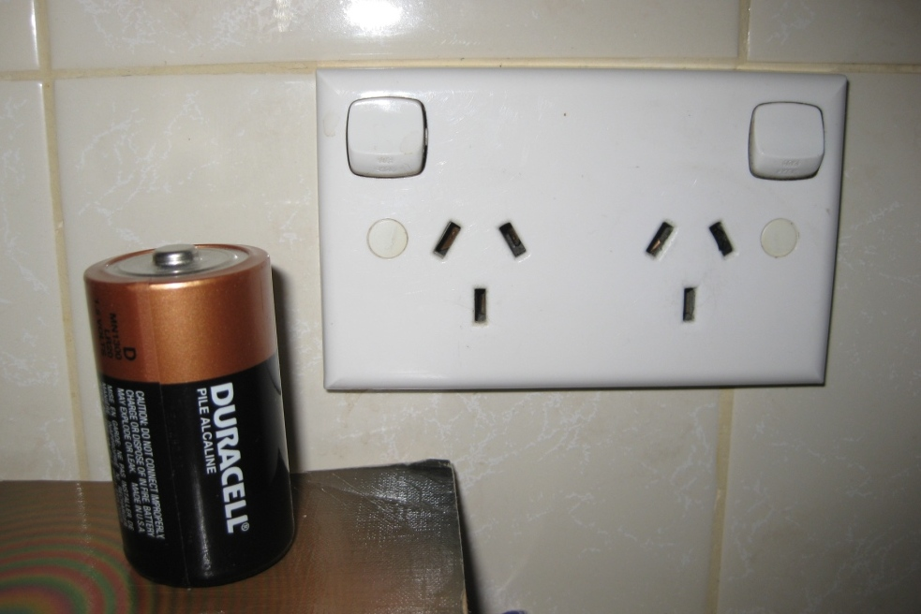

The electricity supply from a household wall socket is not the same as that from a battery.

1. Describe two electrical characteristics for the household wall socket that are different to the battery.

Wall socket supplies AC (alternating current) – battery is DC (direct current) ✓

Much higher voltage available from wall socket. ✓

Or other well justified points.

**(2)**

1. Electric shock is hazardous to the human body. Describe why a person receiving an electric shock is in danger.

**(3)**

Important body functions such as heart, nerve, brain, muscles controlled by small electrical signals. ✓An imbalance from an external source can disrupt these systems with life threatening consequence. ✓

Electric shock can also cause severe burns and cell damage.✓

3 well reasoned points for full marks.

1. What is the value of the potential difference between the Earth wire and the Neutral wire in a household electrical circuit?

**(1)**

Zero ✓

1. 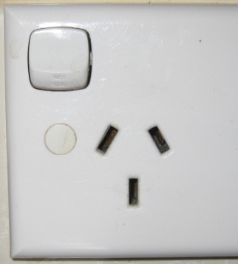Identify the connection to Earth on this picture of a wall socket.

**(1)**

1. Describe the function of the Earth wire in a household electrical circuit.

**(2)**

If a fault occurs within a device, such as the live wire becoming loose, the Earth wire provides a path for current to flow. (A short circuit) ✓

This will usually cause a fuse to blow or other safety components to disable the circuit.✓

It works primarily to protect electrical devices rather than people.

A household electrical circuit includes components that protect people when using electrical devices. The fuse has now been replaced by circuit breakers and residual current devices in new homes.

1. Choose either a ‘circuit breaker’ or a ‘residual current device’ and describe how it protects people from electric shock and why it is better than a fuse.

Circuit breaker – if current higher than the rating of the component is detected the circuit breaker uses electromagnetic effects to switch off the circuit in a very short time. It can easily be reset by the switch on the front.

RCD – monitors the current in active and neutral wires which should be identical. In case of a fault or electrocution occurring there will be a difference. Electromagnetic properties cause the RCD to switch off the circuit within a few milliseconds. Can be easily reset.

Look for 3 good points. ✓ ✓ ✓

**(3)**

**Question 19 [14 marks]**

a



b Rx = 4.1 / 0.12 = 34.2 

c Q = I x t

Q = 0.33 x 5.0 x 60 = 99 C

d V = I x R

1.5 = 0.45 x R

R = 3.33 

e 1/R total = 1/R +1/4R = 5/4R

so R total = 4R/5 = 3.33

4R = 16.65

so the resistance of R is 4.2 

f Ratio of current flowing through the two branches of resistors is 1 : 4

Total current is 0.45 A so the current through N is 0.09 A

g Energy = I x V x t

1.4 x 106 = 0.45 x 12 x t

t = 1.4 x 106 / (0.45 x 12)

time is 2.59 x 105 s = 72 h

**Section 3: Comprehension (16 marks)**

1. It is a difference in temperature which for Kelvin and Celsius would give the same answer. K = C + 273.
2. Jms-1m-2K-1 so it is Jm-1s-1K-1 or Wm-1K-1
3. The lagged bar so that heat flow is along a temperature gradient that is constant.
4. 100 x 0.1/50 x 10-3 = 200 so it is more likely to be a metal
5. Then there would be no conductivity as there would not be a temperature difference to cause the heat to flow. Heat is always being removed from the cold end.
6. The heat flow in to the conducting material will equal the heat flow passing out.
7. The particles are much further apart in a gas compared to a metal which means they have further to travel to pass on the energy.
8. Insulation